

## MVJ College of Engineering,Bengaluru

**(AnAutonomousInstitute)**

Affiliated to VTU, Belagavi, Approved by AICTE, New Delhi, Recognised by UGC with12(f)&12(B), Accredited by NBA&NAAC

**2024-2025**

**“FLOOR CLEANING ROBOT”**

A Mini Project Report

Submitted in partial fulfillment of the requirement for the award of the Degree Bachelor of Engineering

In

## Electronics and Communication Engineering

Submitted by

**AKASH MAHAGAVE 1MJ22EC012**

**GAGAN B K 1MJ22EC046**

**CHETHAN N 1MJ23EC405**

**NITHIN M 1MJ23EC413**

Co-ordinator

## Dr.NijaKS

**Assistant Professor**

Department of Electronics & Communication Engineering

## MVJ College of Engineering,Bengaluru

**(AnAutonomousInstitute)**

Affiliated to VTU, Belagavi, Approved by AICTE, New Delhi, Recognised by UGC with12(f)&12(B), Accredited by NBA&NAAC

**2024-2025**



**MVJ COLLEGE OF ENGINEERING,BENGALURU-560067**

**(Autonomous Institution Affiliated to VTU, Belagavi) DEPARTMENT OF ELECTRONICS AND COMMUNICATION ENGINEERING**

## CERTIFICATE

Certified that titled **“FLOOR CLEANING ROBOT”** is a Bonafide work carried out by **AKASH MAHAGAVE(1MJ22EC012), GAGAN B K(1MJ22EC046), CHETHAN N (1MJ23EC405), NITHIN M (1MJ23EC413)** who areconfide students of MVJ College of Engineering, Bengaluru, of **Bachelor of Engineering in Electronics and Communication Engineering** of the Visvesvaraya Technological University, Belagavi during the year 2024-2025. It is certified that all corrections/suggestions indicated for the Internal Assessment have been incorporated in the mini project report deposited in the departmental library.The mini project report has been approved as it satisfies the academic requirements in respect of mini project work prescribed by the institution for the said Degree.

**Signature of Co-ordinator Signature of Head of the Department Signature of Guidance**

**Dr. Nija K S** Assistant Professor Department of ECE,

MVJ College of Engineering Bengaluru

**Dr.SHIMARAMESH MANIYATH**

HOD Department of ECE MVJ College of Engineering Bengaluru

**Prof. VARSHA P H**

Assistant Professor Department of ECE,

MVJ College of Engineering Bengaluru

**ExternalViva**

**NameofExaminers SignaturewithDate**

**1**

**2**

**(Autonomous Institution Affiliated to VTU, Belagavi) DEPARTMENTOFELECTRONICSANDCOMMUNICATIONENGINEERING**

## DECLARATION

We**, AKASH MAHAGAVE(1MJ22EC012), GAGAN BK(1MJ22EC046), CHETHAN N (1MJ23EC405), NITHIN M (1MJ23EC413), “FLOOR CLEANING ROBOT”**

students of fifth semester B.E., Department of Electronics and Communication Engineering, MVJ College of Engineering,Bengaluru, here by declare that the mini project titledhas been carried out by us and submitted during the year 2024-2025.

Further we declare that the content of the dissertation has not been submitted previously by anybody for the award of any Degree or Diploma to any other University.

We also declare that any Intellectual Property Rights generated out of this mini project carried out at MVJCE will be the property of MVJ College of Engineering,Bengaluru and we will be one of the authors of the same.

Place:Bengaluru Date:

**Names Signature**

**1. AKASH MAHAGAVE 1MJ22EC012**

**2. GAGAN B K 1MJ22EC046**

**3. CHETHAN N 1MJ23EC405**

**4. NITHIN M 1MJ23EC413**

# ABSTRACT

Floor-cleaning robots are an innovative solution to modern cleaning challenges, providing autonomous, efficient, and reliable cleaning capabilities for homes, offices, and industrial spaces. This project aimed to design and develop an autonomous floor-cleaning robot capable of navigating various floor surfaces while avoiding obstacles and optimizing cleaning paths.

The robot integrates a range of hardware components, including sensors (ultrasonic, infrared, or LIDAR), motors, a microcontroller, and a cleaning mechanism consisting of brushes and a vacuum. Software algorithms for obstacle detection, path planning, and cleaning patterns were developed and tested to ensure efficient operation.

Extensive testing demonstrated the robot's ability to clean diverse floor types with minimal human intervention. The results showed high efficiency in terms of area cleaned per minute and battery usage. Furthermore, the robot proved to be an affordable and scalable solution, with potential applications in both residential and commercial environments.

This report outlines the complete process of designing, developing, and testing the floor-cleaning robot while highlighting the challenges encountered and potential areas for future improvement. The project contributes to the growing field of robotics by providing a cost-effective, sustainable, and user-friendly cleaning solution.

# 

# ACKNOWLEDGMENT

I express my sincere gratitude to the Management of MVJ College of Engineering, Bengaluru, for their unwavering support and encouragement during our mini-project work.

I am thankful to **Dr. Ajayan**, Principal of MVJCE, Bengaluru, for his constant inspiration and for providing the necessary facilities throughout the project.

My deep appreciation goes to **Dr.Shima Ramesh Maniyath**,HOD of Electronics and Communication Engineering ,MVJCE, for her consistent support and provision of resources needed for the project.

I am also grateful to our guide, **Dr.Nija K S**,Assistant Professor,Dept.of ECE,MVJCE, for his encouragement and invaluable guidance in the successful completion of the project.

I am in debted to our guide ,**Prof.Varsha P H**,Assistant Professor,Department of Electronics and Communication Engineering for her whole hearted support, suggestion and in valuable advice through out the mini project and also for the help in the preparation of this report.

I extend my thanks to all faculty members of our department for their cooperation and constructive feedback, which significantly aided our project work.

Lastly,I thank my family and friends for their un wave ring support and encouragement. Thank you.

**Certificate Declaration Acknowledgement Abstract**

**II III IV V**

CHAPTER1 1-3

Introduction 2

* 1. AimandObjective 3

CHAPTER2 4-5

LiteratureSurvey 5

CHAPTER3 6-10

Methodology 7

* 1. ProposedSystem 7
  2. Blockdiagramoftheproposedsystem 8
  3. SystemArchitectureofproposedsystem 9
  4. Flowchartofproposedsystem 10

CHAPTER4 11-16

HardwareDescription 12

CHAPTER5 17-20

SoftwareDescription 18

CHAPTER6 21-23

ResultAnalysis 22

CHAPTER7 24-25

CONCLUSION 25

REFERENCES 26-27

|  |  |  |
| --- | --- | --- |
| **FigureNo.** | **Name** | **PageNo.** |
| 3.1 | BlockDiagramoftheProposedSystem | 8 |
| 3.2 | SystemArchitectureoftheproposedsystem | 9 |
| 3.3 | FlowChartoftheproposedsystem | 10 |
| 4.1 | ArduinoUNO | 12 |
| 4.2 | DCGearMotor | 13 |
| 4.3 | Ultrasonicsensor | 14 |
| 4.4 | ICL293DMotordriver | 15 |
| 4.5 | Wheels | 15 |
| 4.6 | Battery | 16 |
| 4.7 | Chassis | 16 |
| 5.1 | ArduinoIDEdefaultwindow | 18 |
| 5.2 | Arduinosetup | 19 |
| 5.3 | SelectingthePort | 20 |
| 6.1 | HardwareDesignoftheProject | 22 |
| 6.2 | WorkingofFloorCleaningrobot | 22 |

# CHAPTER -1 INTRODUCTION

### CHAPTER–1

### INTRODUCTION

Inrecent years,With the advent of low-cost, versatile platformslike Arduino, intelligent and affordable robots for household work have been possible in the recent past. Arduino is an open-source electronics platform that is easy and inexpensive to usefor designing and controlling robots. It's compatible with most sensors, actuators, and motors and, therefore, an ideal choice for building a floor cleaning robot.

The ultrasonic sensors which detect the distance through sounding waves and returning reflection plays an important role in sensing obstacles for the robot. To keep the robot from accidents or collision with furniture walls and other objects, a continuously scanning environment is achieved to guarantee the safety of an efficient cleaning process.

This robot navigates through the floor with ultrasonic sensors and uses an Arduino microcontroller in avoiding all obstacles. Mechanisms of cleaning, such as rotating brushes or vacuum systems for the collection of dirt and debris, are also mounted on the practical solution of cleanliness floors in homes and offices. The combination of Arduino with ultrasonic sensors affords an affordable but very efficient means of automating the cleaning of floors and consequently helps to eliminate labor forces by increasing efficiency.

Thepurposeofthisprojectistodesignandimplementafloorcleaningrobotthatcanclean a room autonomously, detect and avoid obstacles, and provide a cost-effective solution to household cleaning needs.

* 1. **Aimandobjectives:**

#### Aim:

The aim of a floor cleaning robot using Arduino and ultrasonic sensors is an autonomous, inexpensive cleaning solution that could navigate the floor, detect the presence of objects, avoid collision, and effectively clean the surface with minimal human intervention.

#### Objectives:

TheobjectivesofafloorcleaningrobotusingArduinoandultrasonicsensorsare:

1. AutonomousNavigation:Enabletherobottomovefreelyaroundthefloorwithoutmanual control, using sensors to detect its surroundings.
2. Obstacle Detectionand Avoidance:Use ultrasonic sensors to detect obstacles and adjusttherobot's path to avoid collisions while ensuring continuous cleaning.
3. EfficientFloorCleaning:Designacleaningmechanism(suchasabrushorvacuum)that operates while the robot moves, ensuring thorough cleaning of the floor area.
4. Cost-EffectiveDesign:Buildtherobotusingaffordablecomponents,suchasArduinoand ultrasonic sensors, to provide an efficient cleaning solution at a low cost.
5. BatteryEfficiency:Ensuretherobotoperatesforareasonableamountoftimeonasingle charge by optimizing energy consumption during navigation and cleaning.
6. BasicIntelligence: Implementsimpledecision-makingalgorithmstonavigate the robotand clean the environment effectively, including pathfinding and obstacle avoidance.
7. ScalabilityandFlexibility:Allowforfutureimprovementsandexpansions,suchasadding more advanced sensors, better cleaning mechanisms, or automated charging capabilities.

# CHAPTER-2

## LiteratureSurvey

### CHAPTER-2

**LiteratureSurvey**

There are many researches done on surface cleaning robots and a lot of methods have been proposed. Some of them include IR sensors for obstacle detection [1]. The basic concept of IR sensors which is used for obstacle detection is to transmit an infrared signal. When an infrared signal strikes the surface of an object, a portion of the signal bounces back and the signal is received at the receiver. The disadvantage of using infrared sensors as obstacle detector is that the robot cannot be operated in a dark room as an infrared sensor is sensitive to light. The important part in a surface cleaning robot is that it should clean the complete room in a specified path. There are many algorithms used.

One of the most common algorithms used is random cleaning algorithm [2][3]. In randomcleaning, the robot moves forward until it detects an obstacle. As soon as the robot detects an obstacle, the robot stops and checks if it has to turn left or right. A distance threshold value is set for the ultrasonic sensors which are mentioned in the source code. When the distance is lower than the threshold value, the robot takes an action to avoid obstacles. The main objectiveof the random cleaning algorithm is to clean the surface by avoiding obstacle. However, the efficiency is less compared to other algorithms. The other algorithm used is the rectangular algorithm [6].

In order to avoid obstacles, some robots use bumpers in the front [5]. For the robot to communicate with the user, many techniques are used. RF transmitter/receiver and Bluetooth are the common techniquesused [4]. The RF transmitter and receiver modules operate at 433MHz.ByusingtheRFmodule, theconsumptionof power isless.Fordatatransmission,the receiver and transmitter are interfaced to the microcontroller.The disadvantage of RF transmitter and receiver is that it has a very less range as compared to other communication modules. The other method for the robot tocommunicate withthe user is by usingBluetooth module [7][8].

Advanced robots which are used for navigation can be implemented by mapping techniques using SLAM [9]. SLAM generates or updates maps of anunknown location by simultaneously keepinga track of the user. Several papers focus on the design and development of autonomous floor cleaning robots, highlighting the system architecture, hardware integration, and programming techniques. They emphasize the importance of sensor calibration, obstacle detection algorithms, and intelligent path planning for efficient coverage and navigation.

# CHAPTER -3 METHODOLOGY

### CHAPTER-3

### METHODOLOGY

#### ProposedSystem:

The development of a floor cleaning robot using Arduino with ultrasonic sensors involves many technical challenges related to the operation and effectiveness or efficiency. Obstacle detection is the most basic problem for such sensors since, even though they are effective, they have limitations in terms of range, accuracy, and a possibility of interference from the irregularly shaped objects or even reflective surfaces. The robot should be able to move around the environmenton its own, avoiding collisions and ensuring that the entire floor is cleaned.

One of the main challenges in achieving efficient path planning is that the robot has to cover the entire floor without retracing its path or missing areas. The Arduino microcontroller has to control movement and the cleaning mechanism while processing sensor data in real-time, which can strain computational resources. Management of battery life is also paramount; the robot works wirelessly. All this notwithstanding, several solutions were realized, including using multiple sensors and optimizing the pathfinding algorithm by incorporating an automated rechargingsystem.

* + 1. AutonomousNavigation:Therobotmustnavigatearoundthecleaningareawith effectiveness in moving around obstacles and boundaries.
    2. ObstacleDetectionandAvoidance:Therobotshouldsensetheobjectsinitspath (furniture, walls, or any other obstacle)and change the path in order to avoid collision.
    3. Floor CleaningMechanism: It should be equipped with an efficient cleaning system,forexample, a rotating brush or mop.
    4. ChargingandBatteryManagement:Therobotshouldhavetheabilitytoreturntoits charging station once the battery is low.
    5. AreaCoverage:Therobotshouldcovertheentirefloorareawithaminimalamountof redundancy.

#### BlockDiagramoftheproposedsystem:

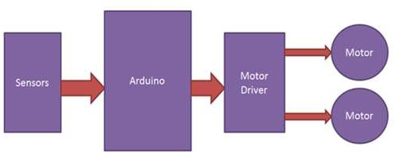

Fig3.1BlockDiagramoftheproposedsystem.

**Power source:** This will supply all the needed voltage and current for powering the entire robot system. It could be a rechargeable battery, say, Li-ion or Li-poly to keep running the robot wirelessly.

**Arduinoboard:**Theheartofthecontrolunitinarobotis anArduino(likeArduinoUnoorNano). It reads data coming from sensors and controls its output to motors. It applies logic on its route- finding ability to clean up and get out of obstacles.

**Motor driver:** This module isan interfacebetween theArduino andthe motors. It receives signals from the Arduino to control the rotation direction and speed of the DC motors, which drive the wheels and the vacuum motor. Common motor driver ICs include L298N or L293D.

**DC Motors:** These are used to drive the robot's wheels, making the robot move forward,backward, and turn. The motor driver will determine their direction and speed.

**Brush motor:** Certain cleaning robots for floors come equipped with rotating brushes that accumulate dirt and dust. It is a motor that will power the brush and be in conjunction with the vacuum motor to clean the floor more efficiently.

#### SystemArchitectureoftheproposedsystem:

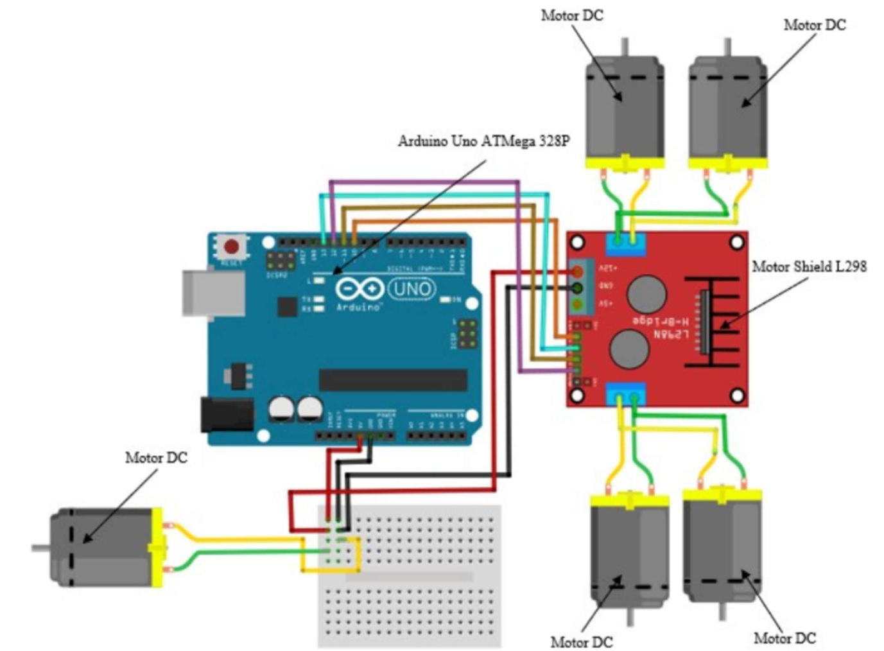

Fig:3.2SystemArchitectureoftheproposedsystem.

The Arduino Uno machine may be examined on an automated ground cleansing robotic prototype within side the following steps:

* + 1. Connect the battery to the device's hardware assembly. prototype of an automatic floor cleaning robot and turn it on the button.
    2. Following that, the prototype of an automatic floor cleaning robot will be activated in the same way as the supporting devices, namely Arduino Uno, Ultrasonic Sensor, Motor Shield L298, Servo, and other components Dc motor.
    3. Following the final touch of the automated ground cleansing robotic prototype, the ultrasonic sensor is related to its assisting devices. will discover the space among factors this is an obstacle.
    4. When the automatic floor cleaning robot prototype detects a distance that is anobstacle.

#### FlowChartoftheproposedsystem:

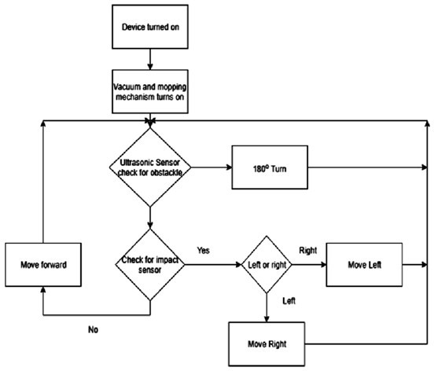

Fig3.3FlowChartoftheproposedsystem.

This figure illustrates a simplified flowchart of the working of the robot. When the bot is switched on the suction and mopping mechanism turns on, then ultrasonic sensor checks for the presence of any head on obstacles.In case of any head-on obstacles, it takes a clockwise or ananti-clockwise turn, in case of absence of obstacles, it checks for any impact on the bumpers. If thereis any impact, the robot moves away from the impacted object and if there is no impact, then it moves forward and checks for any head-on obstacles and the loop continues.

# CHAPTER-4

## HardwareRequirements

### CHAPTER-4

**HARDWAREREQUIREMENTS**

In the realm of modern technology, the amalgamation of hardware components forms the backbone of countless innovative projects. Our project Floor cleaning robot stands as a testamentto this synergy, incorporating a diverse array of hardware components to achieve its objectives effectively. The following hardware requirements comprise the foundational elements that drivethe functionality and capabilities of our project:

#### ArduinoUNO:

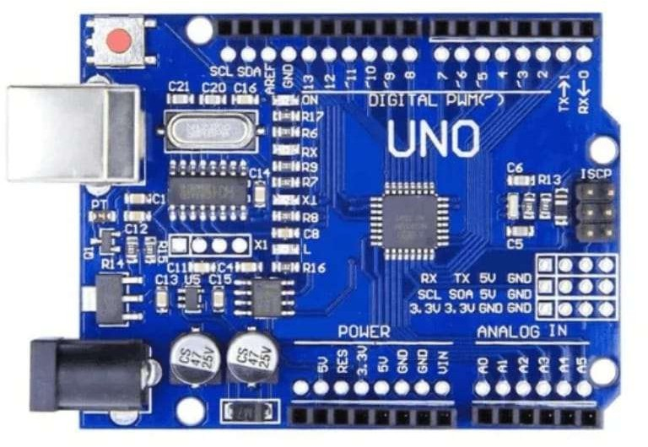

Fig4.1ArduinoUNO.

The Arduino Uno is a microcontroller board that serves as the brain of Floor-cleaning robots, providing the processing power and connectivity to integrate various sensors, motors, and control algorithms. Its ease of use, flexibility, and open-source nature make it an ideal choice for robotics applications. Arduino is widely used in floor cleaning robots to control and automate various functions. It manages sensors for detecting obstacles, dirt, and edges, processes motor movements for navigation, and controls cleaning mechanisms.

#### DCGearMotor:

A DC motor is an electric motor that converts electrical energy into mechanical energy. It operates based on the principles of electromagnetic induction and consists of a rotor (the rotating part) and a stator (the stationary part). DC motors are commonly used in various applications such as robotics, automation, and industrial machinery.

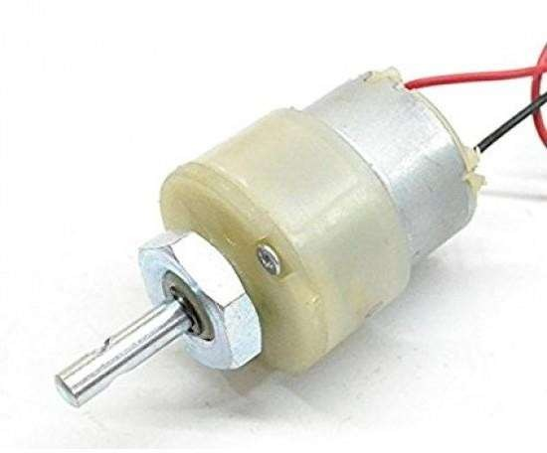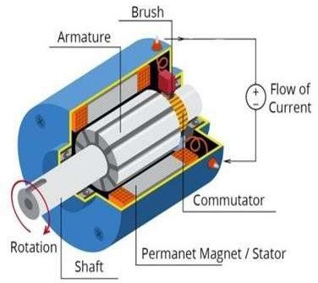

Fig4.2DCGearMotor.

#### Features:

**Variablespeedcontrol:**DCmotorscanbecontrolledtooperateatdifferentspeedsbasedon the applied voltage and current.

**Direction control:** They can rotate in both clockwise and counterclockwise directions, allowing for versatile mechanical operations.

**Torqueoutput:**DCmotorscandeliverhightorqueoutput,makingthemsuitablefortasks requiring power and force.

**Compact size:** Many DC motors are compact insize, making them suitable for integration intovarious devices and systems.

**Efficiency:**DCmotorsareknownfortheirenergyefficiency,convertingelectricalenergy into mechanical energy with minimal losses.

#### UltrasonicSensor:

An ultrasonic sensor is a device that uses ultrasonic waves to measure distance or detect objects. It emits ultrasonic pulses and calculates the time taken for the pulses to bounce back after hitting an object. Ultrasonic sensors are commonly used in robotics, automation, and security systems for proximity sensing and object detection.

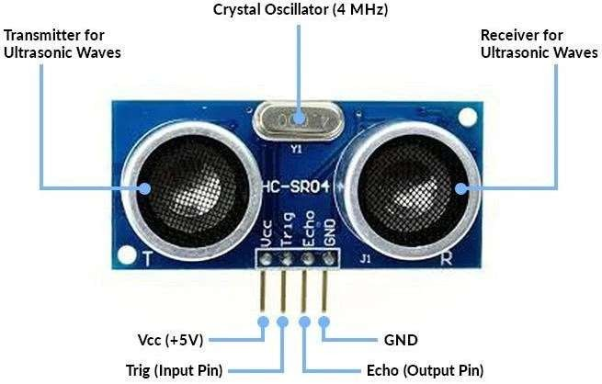

Fig4.3Ultrasonicsensor.

#### Features:

**Distancemeasurement:**Ultrasonicsensorsaccuratelymeasuredistancesbycalculatingthe time taken for ultrasonic waves to travel and return.

**Objectdetection:**Theycandetectobjectswithintheirdetectionrange,makingthemsuitable for collision avoidance and proximity sensing.

**Non-contactoperation:**Ultrasonicsensorsoperatewithoutphysicalcontact,reducingwearand tear and enabling non-invasive sensing.

**Adjustablesensitivity:**Manyultrasonicsensorsallowforadjustablesensitivitylevels,optimizing performance for different environments.

**Weatherresistance:**Someultrasonicsensorsaredesignedtowithstandharshenvironmental conditions, including temperature variations and moisture.

#### ICL293DMotordriver.

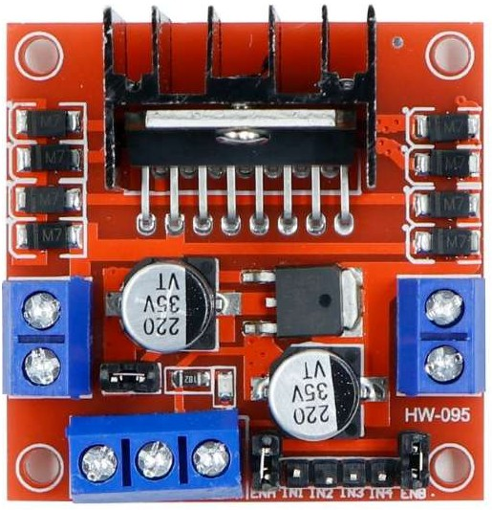

Fig4.4ICL293DMotordriver.

The L293D motor driver is a crucial component in floor-cleaning robots, enabling the precise control of DC motors that power the robot's movement. This integrated circuit is specifically designed to drive inductiveloads, such asmotors, and providesa high-current output, making it ideal for applications requiring rapid acceleration and deceleration.

#### Wheels.

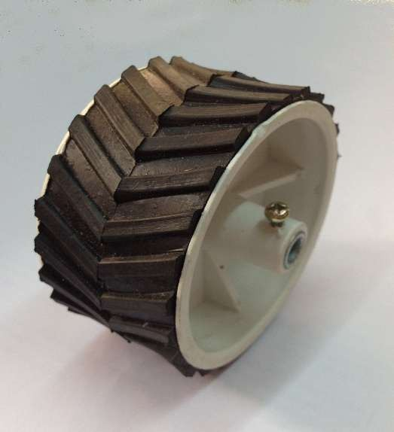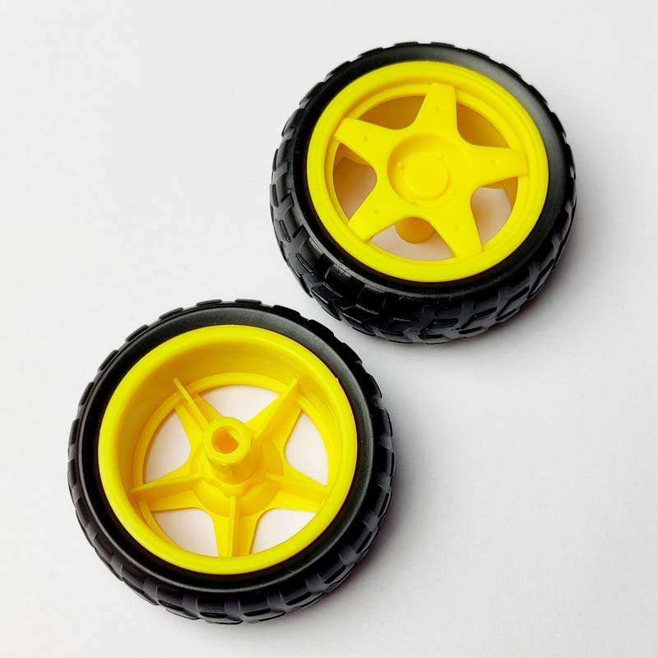

Fig4.5Wheels.

The wheels of a floor-cleaning robot are essential parts that allow the robot to move. smoothly and efficiently. The design and selection of wheels depend on the robot's intended environment, payload, and speed requirements.

#### Battery:

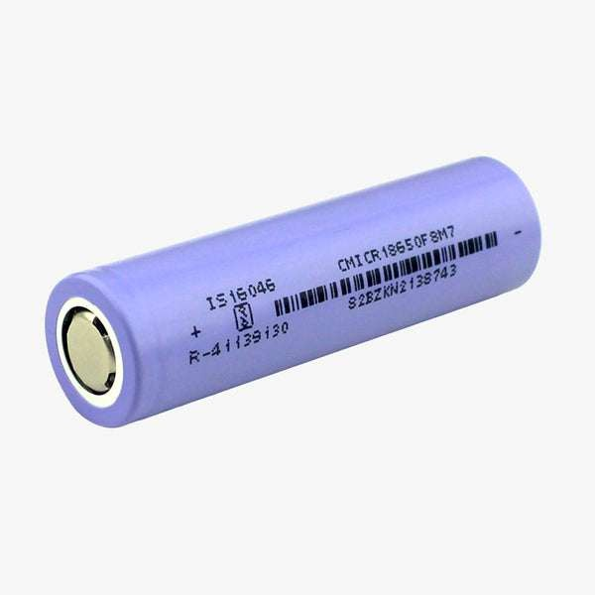

Fig4.6Battery.

The battery is one of the most important components in floor-cleaning robots, providing the power needed to make the robot move, sensors function, and process information. A reliable and efficient battery ensures uninterrupted operation, making the robot clean for long periods without needing to recharge.

#### Chassis:

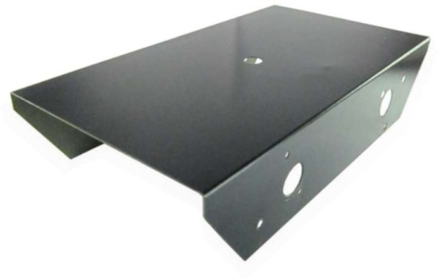

Fig4.7Chassis.

A floor cleaning robot chassis using Arduino can be built with a lightweight material like plastic or acrylic. It should include DC motors for movement, motor drivers, and wheels for mobility. Attach ultrasonic sensors for obstacle detection, and a rotating brush motor forcleaning. Power the system with a rechargeable battery. Mount the Arduino and motor driver securely, and connect all components for efficient operation and control.

# CHAPTER-5

**SoftwareRequirements**

# CHAPTER-5

### SoftwareRequirements

#### ARDUINOIDE:

Arduino IDE (Integrated Development Environment) is a software platform designed for programming Arduino microcontrollers. It provides a simplified programming environment that abstracts manylow-level details, making itaccessible for userswithlittle orno prior programming experience.

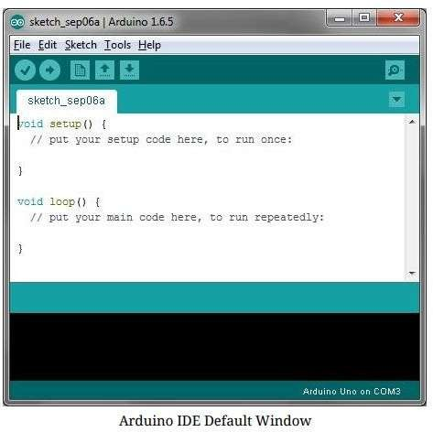

Fig5.1ArduinoIDEdefaultwindow.

**Programming Language:** Arduino IDE uses a programming language that is based on C andC++. It provides a high-level interface that simplifies programming concepts, making it easier for beginners to get started. Thelanguageincludes built-in functions andlibrariesspecific to Arduino, allowing users to interact with the microcontroller's hardware features.

**Digital Input/Output (I/O):** The Arduino Uno board has a set of digital input/output pins (GPIO) that can be configured as either input or output. These pins allow users to read digital signals from external sensors or control digital output signals to interact with actuators or other devices.

Analog Input: The Arduino Uno has a few analog input pins that allow users to read analogvoltage values from sensors. These analog pins use an analog-to-digital converter (ADC) toconvert the analog signals into digital values that can be processedby the microcontroller.

You must tell the Arduino IDE what board you are uploading to. Select the Tools pulldown menu and go to the Board. This list is populated by default with the currently available Arduino Boards that are developed by Arduino. If you are using another board/clone, select that board.

#### IDE:COMPortSetup:

When working with an Integrated Development Environment (IDE) that supports serial communication, setting up the COM port is a crucial step for establishing a connection between your computer and external devices or microcontrollers. Here's the theory behind IDE COM port setup

Communication Port (COM Port): COM ports are serial ports on your computer used for serial communication. They are typically represented by a number (e.g., COM1, COM2) and areessential for establishing communication with external devices.

Serial Communication: Serial communication is a method for transferring data one bit at a time sequentially over a single communication line. It is commonly used for connecting microcontrollers, sensors, and other peripherals to a computer.

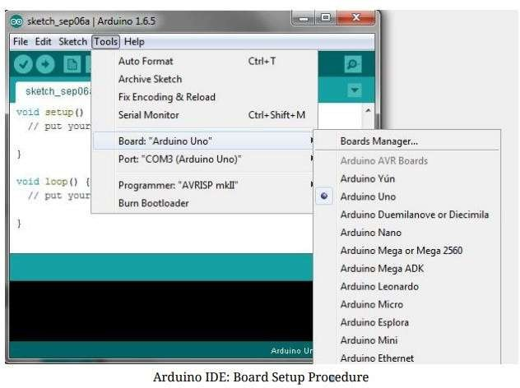

Fig5.2ArduinoSetup.

**Choosing the Correct COM Port:** When using an IDE that supports serial communication, you need to select the correct COM port to establish communication with your target device. The COM port represents the physical connection through which the data will be transmitted and received.

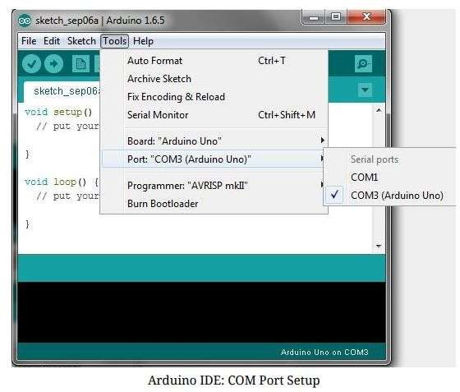

Fig5.3SelectingthePort.

# CHAPTER-6

## AnalysisandResults

### CHAPTER-6

### AnalysisandResults

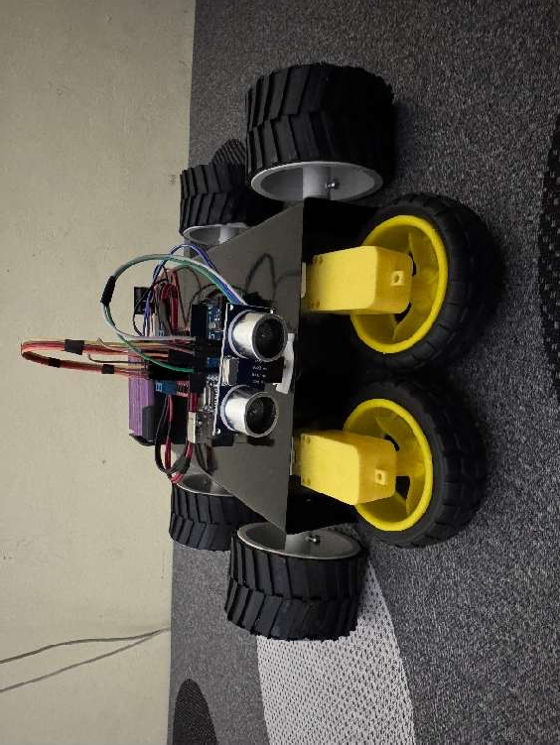

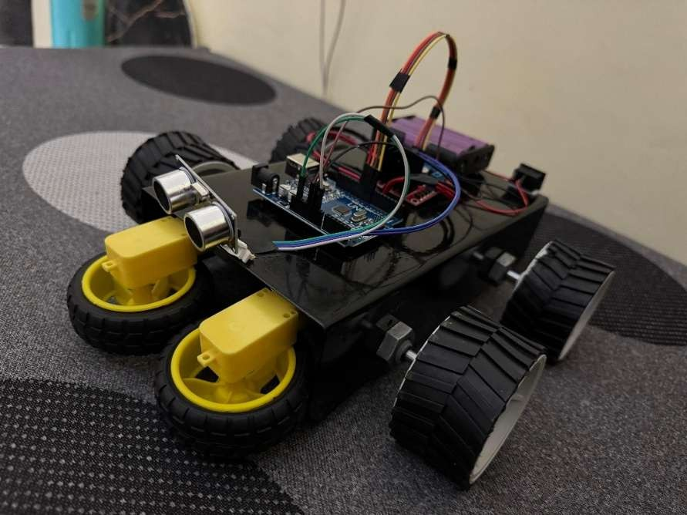Fig6.1:HardwareDesignoftheProject.

Fig6.2:WorkingofFloorCleaningrobot.

The floor cleaning robot that was developed using Arduino and an ultrasonic sensor demonstrated effective performance when detecting and avoiding obstacles while performing simple cleaning tasks. The ultrasonic sensor reliably detected the presence of objects within the predefined threshold, thus preventing the robot from continuing along its direction when encountering any obstacles, which could help in preventing collisions with walls andfurniture.

However, it wassomewhatdisadvantagedinhighlyreflective surfaces environments,and it would inaccurately measure distance. In general, its movement in smaller spaces was efficient, but the robot had difficulties optimizing its path in larger or more complex environments due to using basic obstacle avoidance algorithms, such as random turning or wall-following.

The cleaning mechanism, whether a rotating brush or vacuum, was adequate for small rooms butlost effectiveness inlargerareasduetolimitedcoverage.Thebattery life wassufficient for smaller cleaning cycles but required recharging for longer tasks. When the battery level became low, the robot successfully navigated back to a charging station. Although it is efficient and sufficient for simple scenarios, the system requires advanced sensors, smarter algorithms to navigate, andbattery lives to improve itsperformancesfor larger, more intricate environments.

More advanced improvements would come along with SLAM - which is Simultaneous Localization and Mapping for further advancements in path planning-and in cleaning and power systems for longer and longer autonomy and efficiency.

# CHAPTER -7 CONCLUSION

### CHAPTER-7

### CONCLUSION

In conclusion, the floor cleaning robot using Arduino with ultrasonic sensors offers a promising solution to automating household cleaning tasks in an efficient and autonomous manner. With an Arduino microcontroller integrated with ultrasonic sensors, this robot can efficiently navigate its environment, detect obstacles, and avoid collisions to clean the floor perfectly without human intervention. The ultrasonic sensors would play a critical role toprovide the robot with a real-time distance measurement enabling it to map its environment and make intelligent decisions on where to move and clean the paths. This functionality gives the robot the ability to operate in rooms with furniture or even in narrow spaces.

The Arduino platform forms the heart of the robot and is easy to program. It can be modified further for any future upgrade. The system is simple and can be developed with low- cost components, making it economical for the consumer. Other features like edge detection, automatic charging, or even remote control can be integrated into the robot to increase usability and convenience.

This ensures thattherobotis capable ofavoidingobstacles, preventingdamagetofurniture, and smooth operation. The room mapping capability with adjustment in path based on detected distance further adds a sophistication layer to the system. In addition, the robotic solution will save time and energy by allowing the users to concentrate on other activities while the robot takes care of the cleaning process.

Ultimately, this project shows the possibility of combining basic robotics, sensor technology, and Arduino to create a functional and affordable floor cleaning robot. As technology advances, further improvements could lead to more advanced models capable of performingmore complex cleaningtasks,makingautonomoushome cleaningan integralpart of modern living.

### REFERENCES

1. S. P. Sankhe, A. P. Thakre, and A. N. Damahe, "Design and Fabrication of Floor Cleaning Robot using Arduino," International Journal of Advanced Engineering Research and Science (IJAERS), vol. 5, no. 2, pp. 22-28, 2018.
2. S.R.Rajpurohit,V. A.Pawar,S.R.Patil,andD.M.Pawar,"DesignandImplementation of Autonomous Floor Cleaning Robot using Arduino," International Journal of Scientific Research in Science, Engineering and Technology (IJSRSET), vol. 3, no. 5, pp. 1561-1566, 2017.
3. R. R. Shinde, S. M. Sangve, and P. S. Kale, "Autonomous Floor Cleaning Robot using Arduino," International Journal of Science and Research (IJSR), vol. 6, no. 6, pp. 705-708,2017.
4. V. M. Joshi, V. V. Vaidya, and S. A. Sutar, "Design and Fabrication of a Floor Cleaning Robot Using Arduino Microcontroller," International Journal of Innovative Research inScience, Engineering andTechnology (IJIRSET), vol. 5, no. 4, pp. 4758-4763, 2016.
5. P. H. Apte and P. P. Khade, "Arduino Based Autonomous Floor Cleaning Robot with Obstacle Detection and Floor Mapping," International Journal of Advanced Research in Electronics and Communication Engineering (IJARECE), vol. 6, no. 4, pp. 17-20, 2017.
6. A. A. Kareem and A. A. El-Sharkawy, "Design and Development of an Autonomous Floor Cleaning Robot," Journal of Engineering Sciences, Assiut University, vol. 45, no. 4, pp. 1059- 1080, 2017.
7. S. H. Patel, D. D. Patel, P. V.Patel, and A. R. Shah, "Development of Floor CleaningRobot usingArduino,"InternationalJournalofAdvancedResearchinElectronicsand Communication Engineering (IJARECE), vol. 6, no. 4, pp. 43-47, 2017.
8. D.Pawar, P. Mahapadi, A. Anwekar, andS.Rupnar,"FloorCleaningRobot usingArduino," International Journal of Engineering Research & Technology (IJERT), vol. 4, no. 3, pp. 124- 128, 2015.
9. S. Shinde and S. Mane, "Implementation of Floor Cleaning Robot Using Arduino UNO," International Journal of Engineering Research & Technology (IJERT), vol. 6, no. 8, pp. 640- 645, 2017.